

**UNIVERSITY OF PETROLEUM AND ENERGY STUDIES**

**School of Computer** **Science**

**2020-21**

**GRAPHICS AND ANIMATION TOOLS LAB**

**Faculty: Dr. DURGANSH SHARMA**

**Assistant Professor**

**Department of Cybernetics.**

**School of Computer Science, UPES**

**Submitted By:**

**Name- Vaibhav Kansal**

**Roll no-R100217086**

**Batch-B3**

**Semester- 7**

**Course-B.tech. CSE-OSOS**

**Sap Id- 500061579**

**EXPERIMENT NO-8**

**Aim** :- Design of 3D Car using Blender.

**Steps to create a 3D car**

1. Make another document in a blender.

2. Import a picture of the vehicle for reference.

3. Adjust the shape to the front segment of the vehicle, duplicate this block by squeezing

"Move + D" and afterward place it to frame a rough model of the vehicle

4. Snap alter the mode and use vertex select to change the state of our model

5. Presently use face choose and expel choice to make headlights, windshield

furthermore, mirrors.

6. Again use vertex select and make space for vehicle wheels.

7. Press "Move + A" and add a circle, scale and expel it lastly place it

in a suitable position.

8. Select internal appearances of the circle and expel it to make edges of the vehicle

9. Do the minor changes in the shape to make it look more

streamlined.

10.Now erase the point light source, and add another light source as Sun

11.Set the ability to 7 and spot it someplace over the vehicle

12.Create new material with a shade of your inclination and allot it to the

vehicle object

13.Reduce unpleasantness and do different changes

14.Similarly set the tone for tires, headlights, and windshield

15.Render the item.

16.Finish.

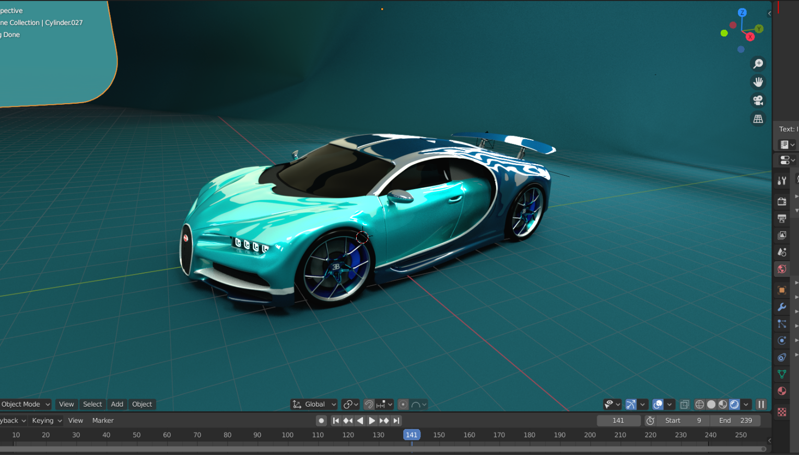

**Google link-** https://drive.google.com/drive/folders/1Hn6mSDEh4BQ8jlLcT3InFoG24j62jqer?usp=sharing